L8-W8-DBS301-Set Operators

This is the week after the break

Do not submit the quiz. Answers available in the Oracle notes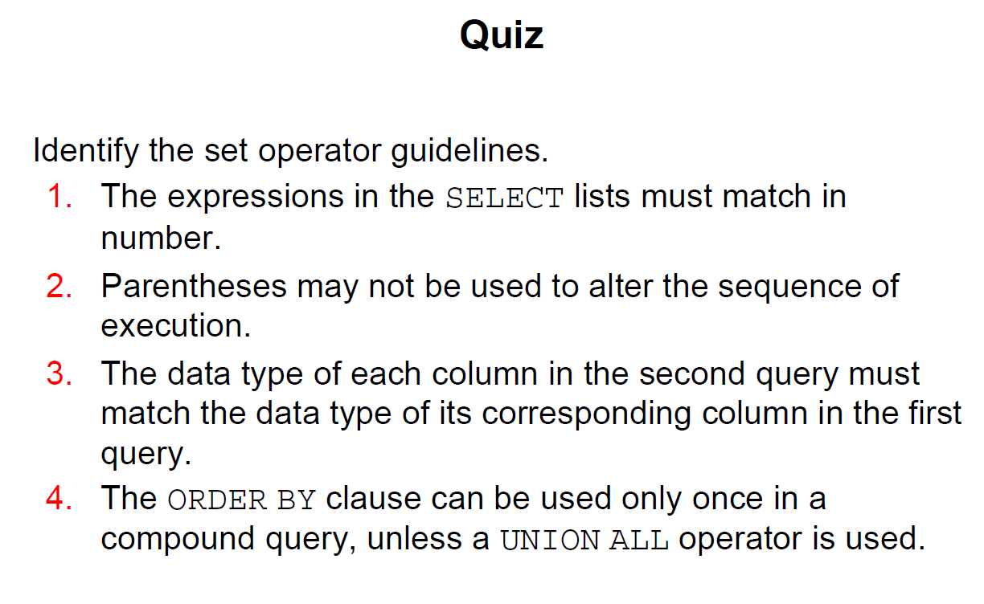

**THE ANSWER TO THE ABOVE IS 🡺 1, 3**

1 The HR department needs a list of Department IDs for departments that do not conbtain the job ID of ST_CLERK> Use a set operator to create this report.

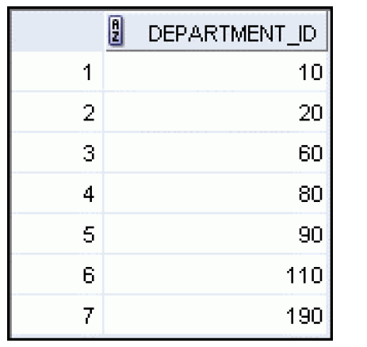

2 Same department requests a list of countries that have no departments located in them. Display country ID and the country name. Use SET operators.

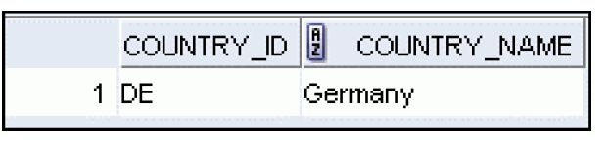

3 The Vice President needs very quickly a list of departments 10, 50, 20 in that order. job and department ID are to be displayed

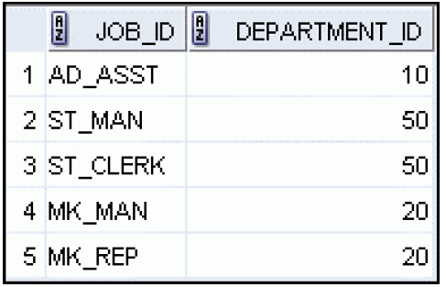

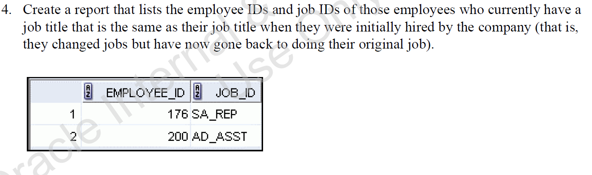

# EXTRA QUESTION

# Try doing it without looking at the answer

